**Melbourne House Prices**

Author: Jose Manuel Alvarez Gonzalez

Email Id: [alvjy005@mymail.unisa.edu.au](mailto:alvjy005@mymail.unisa.edu.au)

Date: 1/2/2022

**Report Summary**

The following report works with a data set on prices of houses sold in Melbourne during February 2017. We will focus on two explanatory variables: Region and Multiple Bathrooms. The sold price will be our response variable, we will work with a significance level of 5%.

**ANOVA**

For this part, a two-way ANOVA will be performed to analyse the effect of the explanatory variables on the house prices.   
First, we visualise the data:

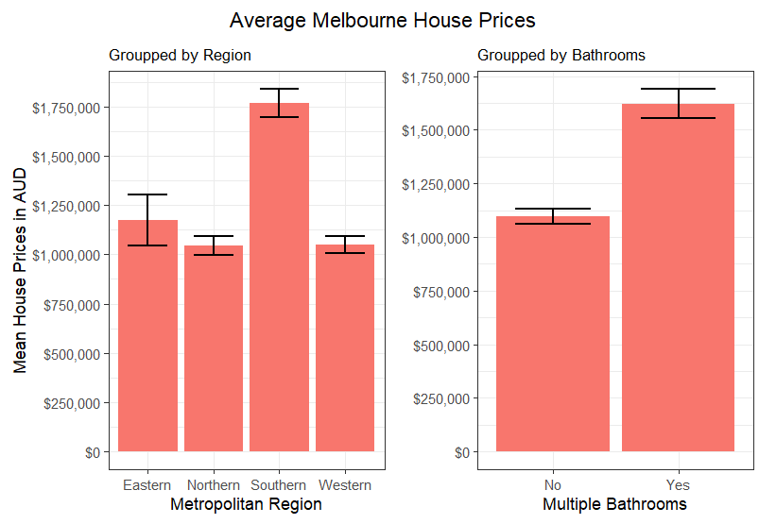

Figure 2, bar plot with factors interactions

Figure 1, bar plot for each factor and their levels

From figure 1, we can identify that for the levels on both explanatory variables there are some differences on means. For figure 2, is not clear to see any difference between the interactions, as prices are always higher when we have multiple bathrooms.

Next, we perform a logarithmic -> Ln(x) transformation to our price variable to fit our ANOVA model. Before using the model, we check for normality and variance homogeneity, the transformed response variable passes both tests.

The test revealed that there is no statistically significant interaction between the effect of both factors together, with a p-vale of 0.486. The simple main effects of Region and Multiple Bathrooms do have statistical significance on the response, with p-vales less than alpha on both cases.

Figure 3, ANOVA table with interactions

Adjusted R-squared is moderate, meaning that 39.19% of the response variation can be explained by the two factors and their interaction. The remaining is explained by other variables not included.

Based on the ANOVA results, I will exclude an interaction plot as this doesn’t add any new information to our report.

**Tukey Test**

Now we perform a one-way ANOVA to compare the effect of Region on house prices with Multiple Bathrooms. The test revealed that there was significant difference in house prices between at least two regions, with a p-value less than alpha.

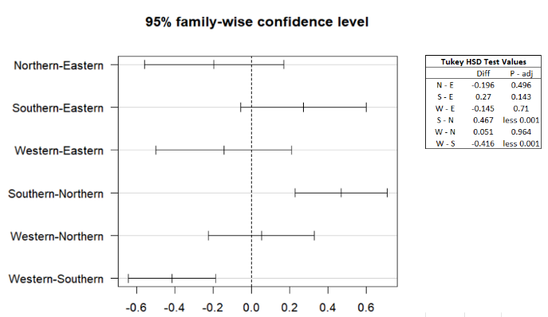

A post hoc Tukey test, found statistical enough difference in mean house price between:

* **South – North**, difference of 0.467
* **West – South,** difference of -0.416

Average house price in the South region is significantly different from the North and West region.

Figure 4, Tukey plot and main values table